#include<iostream.h>
#include<conio.h>
#include<stdio.h>
int length (char a[])
{
int len=0;
for(int i=0;a[i]!='\0';i++)
{
len++;
}
return len;
}
void read(char a[])
{
puts("Enter the string") ;
gets(a);
}
void display(char a[])
{
puts(a);
}
void main()
{
char a[50];
read(a);
display(a);
int len;
len=length(a);
cout<<"The length of the string"<<len;

}

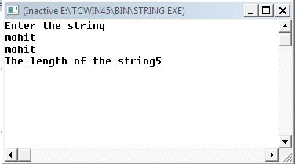

#include<iostream.h>
#include<string.h>
#include<stdio.h>

void revdisplay(char a[])
{
for(int i=strlen(a)-1;i>=0;i--)
cout<<a[i];
}
void reverse(char a[])
{
for(int i=0,j=strlen(a)-1;i<strlen(a)/2;i++,j--)
{
char temp;
temp=a[i];
a[i]=a[j];
a[j]=temp;
}

}
void main()
{
char a[50];
puts("Enter the string");
gets(a);
revdisplay(a);
puts("\nReversed string is:");
puts(a);
reverse(a);
puts("\nReversed string is:");
puts(a);
}

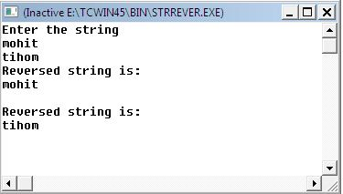

//PROGRAM TO INPUT AND DISPLAY OPERATION ON COMPLEX NUMBER
#include<iostream.h>
#include<stdio.h>
struct complex{int real; int img;};

void input(complex &s);
void add(complex,complex);
void subtract(complex,complex);
void multiply(complex,complex);
void main()
{complex c1,c2; int ch;
cout<<"1st complex no \t";input(c1);
cout<<"2nd complex no \t" ;input(c2);
cout<<"press 1-add, 2-subtract, 3-multiply ";
cin>>ch;
switch(ch)
{case 1:add(c1,c2);break;
case 2:subtract(c1,c1);break;
case 3:multiply(c1,c2);break;
}}
void input(complex &c)
{cout<<"real part ";
cin>>c.real;
cout<<"imaginary ";
cin>>c.img;}
void add(complex x,complex y)
{complex cx;
cx.real=x.real+y.real;
cx.img=x.img+y.img;
cout<<"complex number is "<<cx.real<<"+"<<cx.img ; }
void subtract(complex x,complex y)
{complex cx;
cx.real=x.real-y.real;
cx.img=x.img-y.img;
cout<<"complex number is "<<cx.real<<"+"<<cx.img; }
void multiply(complex x,complex y)
{complex cx;
cx.real=(x.real*y.real)-(x.img*y.img);
cx.img=(x.real*y.img)+(x.img*y.real);
cout<<"complex number is "<<cx.real<<"+"<<cx.img;}

OUTPUT:
1st complex no real part 2 imaginary 3
2nd complex no real part 3 imaginary 4
press 1-add, 2-subtract, 3-multiply>> 3
complex number is -6+17

#include<iostream.h>
#include<stdio.h>
#include<string.h>
struct student
{
int roll, marks;
char name[50];
};
void read(student s[], int n)
{
for(int i=0;i<n;i++)
{
cout<<"Enter the roll no, marks and the name of the student "<<i+1<<" ";
cin>>s[i].roll>>s[i].marks;
gets(s[i].name);
}
}
void sort(student a[], int n)
{
for(int i=n-1;i>0;i--)
{
for(int j=0;j<i;j++)
{
if(strcmpi(a[j].name,a[i].name)>0)
{
student t=a[i];
a[i]=a[j];
a[j]=t;
}
}
}
}
void display(student s[],int n)
{
for(int i=0;i<n;i++)
{
cout<<s[i].roll<<"\t"<<s[i].marks<<"\t";
puts(s[i].name);
}
}
void main()
{
student satan[10];
cout<<"Enter the no. of students";
int n;
cin>>n;
read(satan,n);
sort(satan,n);
cout<<"The sorted array is \n";
display(satan,n);
}

/* Output
Enter the no. of students3
Enter the roll no, marks and the name of the student 1 17
76
Suresh
Enter the roll no, marks and the name of the student 2 23
89
Karan
Enter the roll no, marks and the name of the student 3 8
56
Abhi
The sorted array is
8 56 Abhi
23 89 Karan
17 76 Suresh
*/

#include<iostream.h>
void read(int A[][10], int r, int c)
{ for (int i=0;i<r;++i)
for(int j=0;j<c;++j)
cin>>A[i][j];
}
void display(int A[][10], int r, int c)
{
for (int i=0;i<r;++i)
for(int j=0;j<c;++j)
cout<<A[i][j];
}
void add(int A[][10],int B[][10],int r1,int c1)
{
int C[10][10];
for(int i=0;i<r1;++i)
for(int j=0;j<c1;++j)
C[i][j]=A[i][j]+B[i][j];
display(C,r1,c1);
}
void main()
{
int A[10][10],B[10][10],C[10][10],r1,c1,c2,r2;
cout<<"enter the dimensions of A \n";
cin>>r1>>c1;
cout<<"enter the dimensions of B \n";
cin>>r2>>c2;
if(r1==r2 && c1==c2)
{
read(A,r1,c1);
display(A,r1,c1);
read(B,r2,c2);
display(B,r2,c2);
add(A,B,r1,c1);
}
else
cout<<"addition not possible";
}
OUTPUT
enter the dimensions of A
5
6
enter the dimensions of B
7
2
addition not possible

#include <iostream.h>
void main()
{
int n,i,j,m,q,a;
cout<<"enter a number";
cin>>n;
for(i=n;i>=1;i--)
{
cout<<"\n";
for(j=1;j<=i;j++)
cout<<"*";
}
cout<<"\n"; cout<<"\n"; cout<<"\n";
for(i=1;i<=n;i++)
{
cout<<"\n";
for(j=i;j>=1;j--)
cout<<j;
}
for(m=1;m<=n-1;m++)
{
cout<<"\n";
for(q=1;q<=n-m;q++)
cout<<q;

}

}
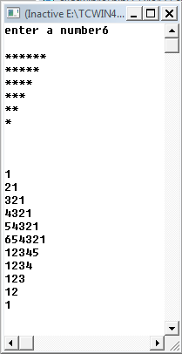
#include <iostream.h>
void main()
{
int i,j,m,q,n;
cout<<"enter a number";
cin>>n;
char ch='a';
for(i=1;i<=n;i++)
{
ch='a';
ch+=(i-1);
cout<<"\n";
for(j=1;j<=i;j++)
{
cout<<ch;
ch--;
}
}

}
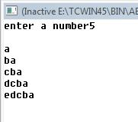

#include<iostream.h>
#include<math.h>
void main()
{
int num,count=0,digit,sum=0,power,n;
cout<<"Enter a number";
cin>>num;
n=num;
do{
num=num/10;
count++;
}while(num!=0);
num=n;
do{
digit=num%10;
num=num/10;
power=pow(digit,count);
sum=sum+power ;

}while(num!=0);
cout<<"the number of digits of the entered number are"<<sum;
if(n==sum)
cout<<"IT IS AN AMSTRONG NUMBER";
else
cout<<" GET LOST IT'S A FAKE NUMBER";

}

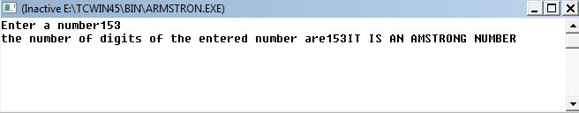

#include<iostream.h>
void read(int a[],int n)
{
for(int i=0;i<n;i++)
cin>>a[i];
}
void display(int a[],int n)
{
for(int i=0;i<n;i++)
cout<<a[i]<<endl;
}
void insertion(int a[],int n)
{
for(int i=1;i<n;i++)
{
int temp,j;
temp=a[i] ;
j=i-1;
while (temp<a[j] && j>=0)
{
a[j+1]=a[j];
j--;

}
a[j+1]=temp;
}
}
void main()
{
int n,a[1000];
cout<<"Enter the size";
cin>>n;
read(a,n);
cout<<"BEFORE SORTING";
display(a,n);
insertion(a,n);
cout<<"The elements after sorting"<<endl;
display(a,n);
}
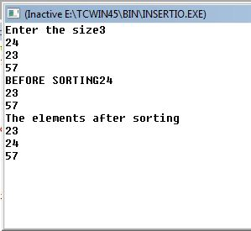
#include<iostream.h>
void read(int[],int);
void display(int[],int);
int large (int[],int) ;
void main()
{
int a[100],n,lar;
cout<<"enter no. of elements";
cin>>n;
read(a,n);
display(a,n) ;
lar=large(a,n) ;
cout<<lar;

}
void read(int a[],int n)
{
for(int i=0;i<n;i++)
{
cout<<"Enter the "<<(i+1)<<"th element\t";
cin>>a[i];
}
}
void display(int a[],int n)
{
for(int i=0;i<n;i++)
cout<<"The"<<(i+1)<<"\t"<<a[i]<<endl;
}
int large (int a[],int n)
{
int lar = a[0];
for(int i=1;i<n;i++)
{
if(a[i]>lar)
{
lar=a[i];
}
}
return lar;
}
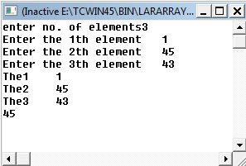

#include<iostream.h>
void read(int [],int);
void display(int [],int);
void selection(int [],int);
int bsearch(int [],int,int);
void main()
{
int a[1000],n,element;
cout<<"Enter the size";
cin>>n;
read(a,n);
cout<<"Before sorting";
display(a,n);
selection(a,n);
cout<<"After sorting";
display(a,n);
int pos;
cout<<" Enter the search item";
cin>>element;
pos=bsearch(a,n,element);
if(pos==-1)
{
cout<<"NOT FOUND ";
}
else
{
cout<<"found at:"<<pos<<endl;
}
}
void read(int marks[],int n)
{
for(int i=0;i<n;i++)
cin>>marks[i];
}
void display(int marks[],int n)
{
for(int i=0;i<n;i++)
cout<<marks[i]<<endl;
}
void selection(int a[],int n)
{
int temp;
for(int i=0;i<n;i++)
{
for(int j=i+1;j<n;j++)
{
if(a[j]<a[i])
{
temp=a[i];
a[i]=a[j];
a[j]=temp;
}
}
}
}
int bsearch(int a[],int n,int element)
{
int beg=0,mid,last=n-1,p=-1;
while(beg<=last && p==-1)
{
mid=(beg+last)/2;
if(element==a[mid])
{
p=mid+1;
}
else if(element>a[mid])
{
beg=mid+1;
}
else
{
last=mid-1;
}
}
return p;
}

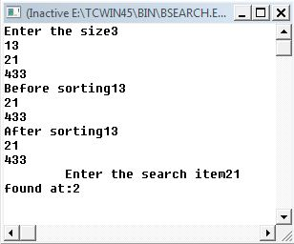

#include<iostream.h>
void bubble(int a[],int n)
{
for(int i=0;i<n-1;i++)
{
int temp;
for(int j=0;j<n-1-i;j++)
if(a[j+1]<a[j])
{
temp=a[j];
a[j]=a[j+1];
a[j+1]=temp;
}
}
}
void read(int a[],int n)
{
for(int i=0;i<n;i++)
cin>>a[i];
}
void display(int a[],int n)
{
for(int i=0;i<n;i++)
cout<<a[i]<<endl;
}
void main()
{
int n,a[1000];
cout<<"Enter the size";
cin>>n;
read(a,n);
cout<<"BEFORE SORTING";
display(a,n);
bubble(a,n);
cout<<"The elements after sorting"<<endl;
display(a,n);
}

